API Manual Helper

Industry Use Case Description: API Manual Helper is designed for the software development and IT services industry, supporting product teams, platform engineers, solution architects, and external developers who work with complex APIs. It enables users to query uploaded API manuals and technical reference documents to quickly retrieve accurate information about endpoints, request and response formats, authentication mechanisms, and error handling. By grounding responses strictly in official documentation, the helper reduces dependency on manual searches and minimizes the risk of incorrect implementation guidance.
This solution is particularly valuable in enterprise environments where APIs evolve rapidly and documentation spans multiple versions or services. It improves developer productivity by providing fast, context-aware answers during integration, debugging, and onboarding workflows. It also supports internal compliance and governance by ensuring that all guidance remains aligned with approved documentation, making it suitable for regulated industries such as fintech, healthcare IT, and SaaS platforms.

System Explanation:
Part 1: Document Upload → Chunk → Embed → Store
1. Google Drive Trigger – Automatically detects when a new API Manual document is uploaded to the monitored folder.
2. Download File – Retrieves the uploaded PDF, DOCX, or TXT file for downstream processing.
3. Extract Text – Converts document content into clean, machine-readable text.
4. Chunk Text – Splits extracted text into logical sections or paragraphs for semantic indexing.
5. Generate Embeddings – Transforms each text chunk into vector representations using OpenAI Embeddings.
6. Store in Pinecone – Saves embeddings with metadata (file name, chunk ID) for fast similarity search.

Part 2: Telegram Query → Search → Respond
1. Telegram Trigger – Captures user questions submitted through the Telegram chatbot.
2. Pinecone Query – Retrieves the top three most relevant API Manual chunks based on semantic similarity.
3. OpenAI Chat – Generates a context-grounded answer using the retrieved API manual content.
4. Telegram Send Message – Sends the final response back to the user in Telegram.

Files Link:
https://cdn.zapier.com/storage/learn_ebooks/e06a35cfcf092ec6dd22670383d9fd12.pdf
https://www.tutorialspoint.com/fastapi/fastapi_tutorial.pdf
Google Drive Link for Sample Files:
https://drive.google.com/drive/folders/1DQUfqmPf27WLsoFGodgJoDFcehU7df2p?usp=drive_link
Github Link for Sample Files:
https://github.com/rajeshksharmasls/GenAI/tree/e899c57f84346d860f2d397a2dde09e40afc40e7/GenAI/Automation/API%20Manual%20Helper/Sample%20Files

Custom System Prompt:
You are a helpful API Manual Helper who only answers questions related to API documentation, including endpoints, request/response schemas, parameters, authentication methods, error codes, and usage examples.
You must generate and summarize answers only from the given context (uploaded API manuals, specifications, or reference documents).
If a user asks an off-topic question, respond exactly with:
“I can only assist with questions related to the uploaded documents.”
If no relevant information or chunks are found in the provided context, respond exactly with:
“I couldn’t find information related to your query in the documents.”
Do not provide any additional information.
Do not generate, infer, or interpret responses using your own knowledge.
Do not answer questions outside the scope of the uploaded API documentation.

Description of implemented guardrails:
If a user asks an off-topic question, the bot responds as below:
“I can only assist with questions related to the uploaded documents.”
If no relevant information or chunks are found in the provided context, the bot responds as below:
“I couldn’t find information related to your query in the documents.”

Screenshots of bot responses for test queries:
Positive Responses
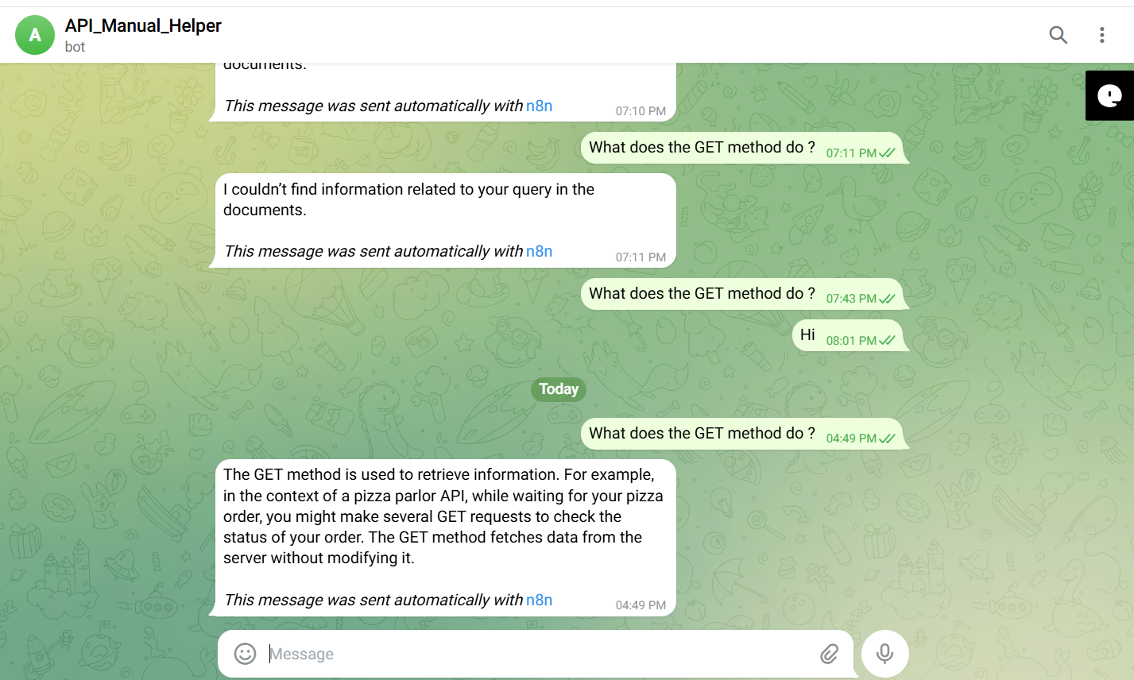
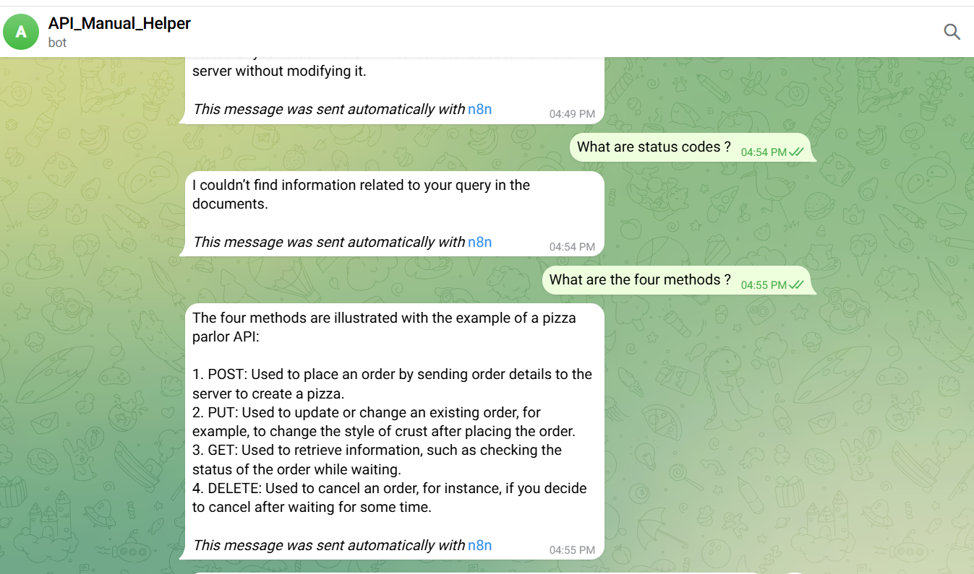
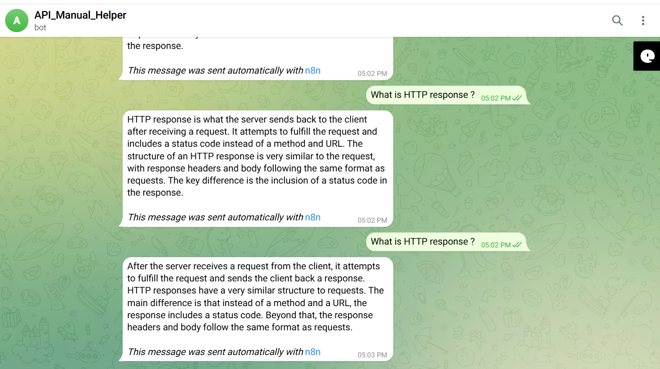
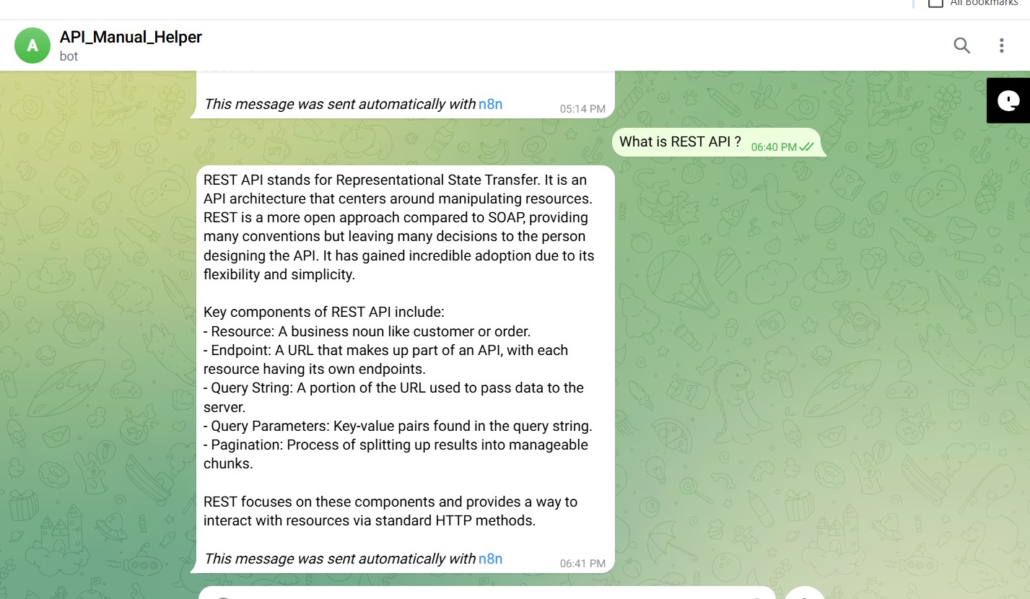

Negative/Off topic Responses
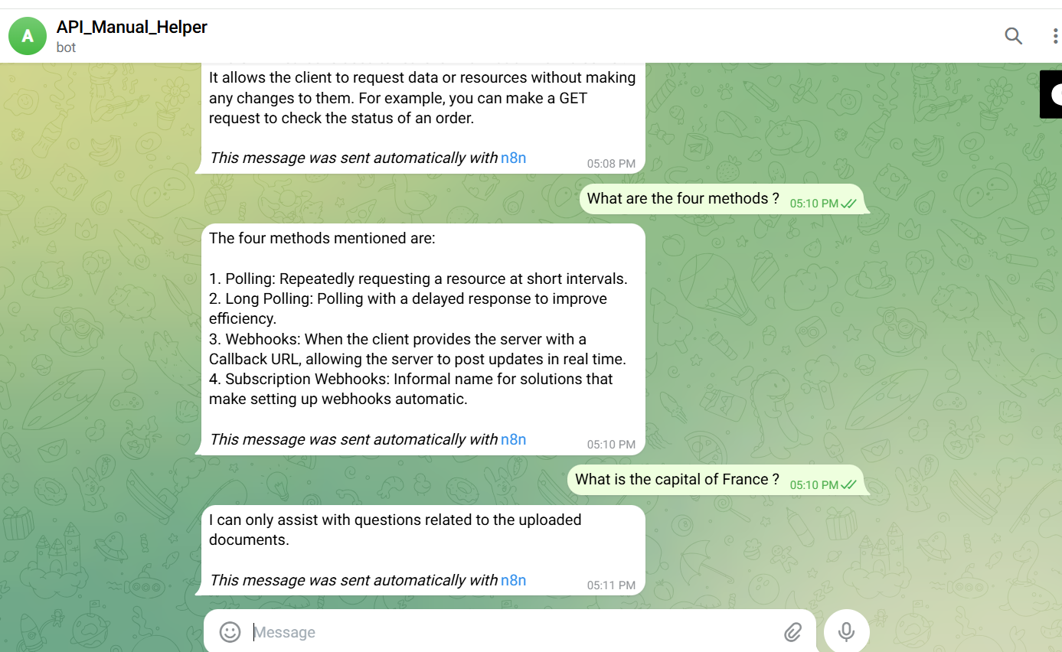
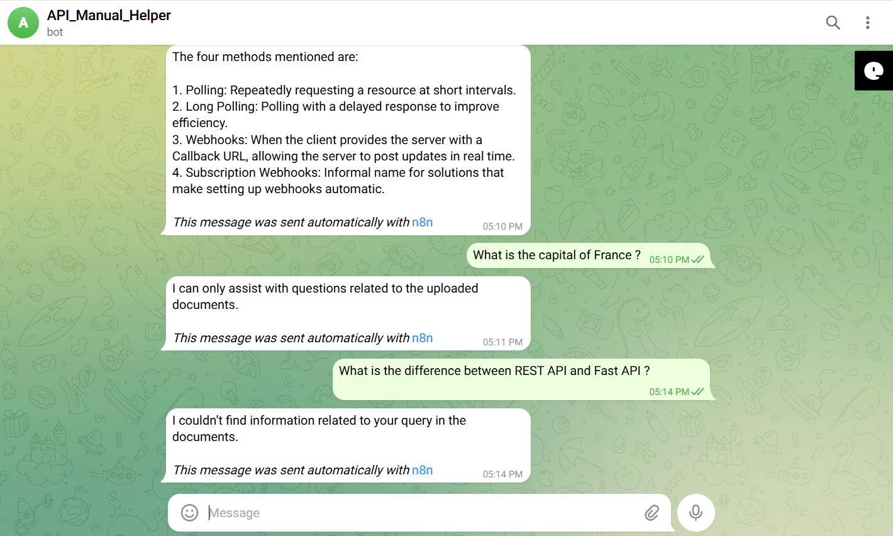

Screenshots of complete n8n flow architecture:
Document Upload:
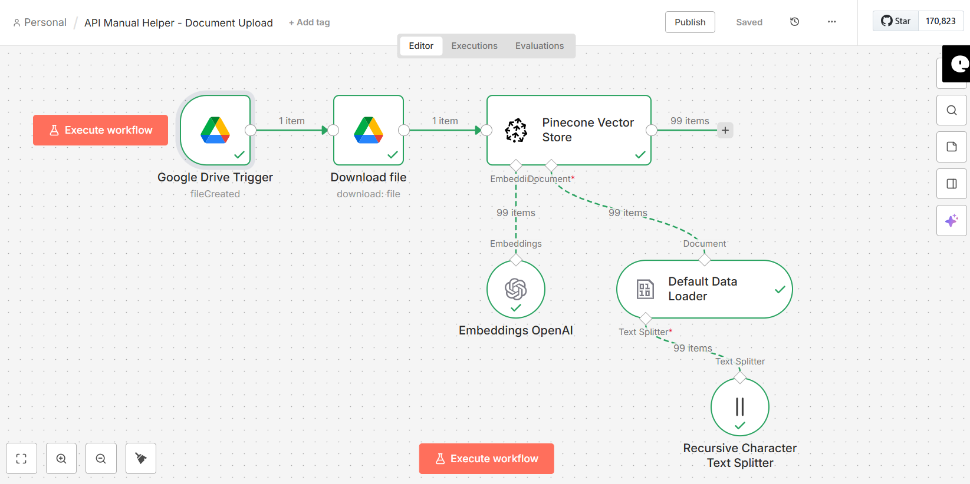
Telegram Bot Flow:
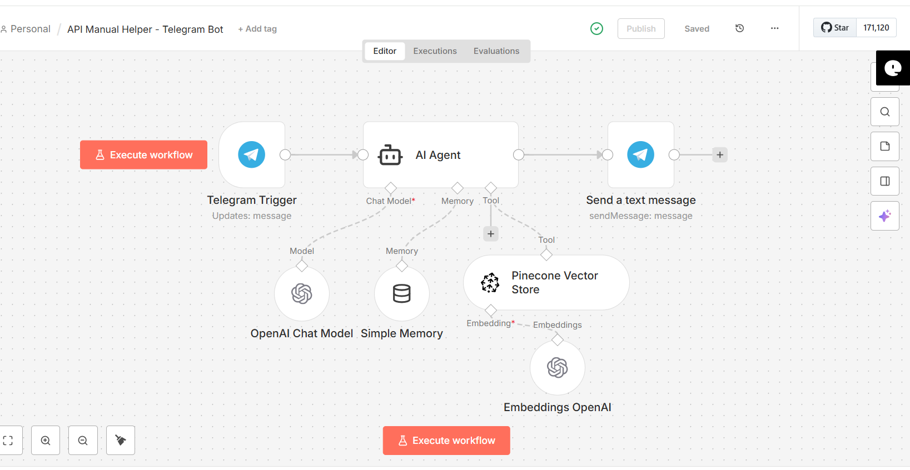

JSON files git hub link:
https://github.com/rajeshksharmasls/GenAI/tree/e899c57f84346d860f2d397a2dde09e40afc40e7/GenAI/Automation/API%20Manual%20Helper/JSON
Demo git hub link:
https://github.com/rajeshksharmasls/GenAI/tree/f9f5207c3c4be73573a80ff824f2960f61bb7655/GenAI/Automation/API%20Manual%20Helper/Demo
Telegram bot username:
api_manual_helper_bot

Challenges faced:
Below are the challenges faced:
- Accurate text extraction from varied API Manual formats, especially scanned or poorly structured PDFs.
- Designing chunking logic that preserves API Manual structure and technical meaning.
- Maintaining high-quality embeddings for domain-specific educational terminology.
- Enforcing strict guardrails to prevent off-topic or hallucinated responses.
- Handling user queries when no relevant API Manual content is retrieved.
- Balancing retrieval depth to avoid missing context or overwhelming the model.

